A brand new perspective

Iain Hand
Alberton Cluster
Alberton Primary School

I have never liked Maths and upon reflection have probably taught my lessons that way. Visual Arts has always been my thing, it engages me, maths did not, and I saw no use or need for it.
Visual Arts and Maths are so closely intertwined.

This year has given me cause for much reflection and the realisation of what a fool I have been. Visual Arts and Maths are so closely intertwined. I use my Maths knowledge everyday while planning and producing works of art. Once I began seeing the path instead of just wandering around it, I became engaged. I wanted my students to become engaged in Maths and to see a purpose and need for Maths.

Doing Maths through Visual Arts has given me that hook; it has given me a brand new perspective on teaching the subject.”

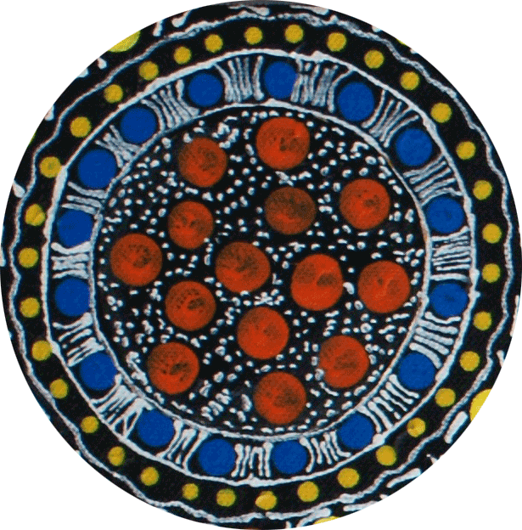
Supporting best teaching of mathematics for Indigenous learners
significant episode

Supporting best teaching of mathematics for Indigenous learners
Professional Knowledge
Know the mathematics content and know the different ways to teach it effectively to Indigenous learners: Be a mathematician, be a learner, be coherent and creative

2.3 Know how mathematics links to contexts beyond the classroom so it can be taught through rich, life-like activities.

“Mathematics content knowledge that teachers need to know has been well researched. They need a profound understanding of fundamental mathematics. When you teach through context, you realise just how much more mathematics there is.” Alberton Cluster

Iain teaches mathematics through visual arts. His story is about being a teacher who didn’t like mathematics and who become more comfortable when he began to teach it through contexts and particularly contexts that he was passionate about. His approach was creative and he taught mathematics through rich activities and contexts that both he and his students revelled in.

Questions to consider:
- What were your own experiences as a school student in the mathematics classroom? How has it impacted on how you teach mathematics and numeracy now?
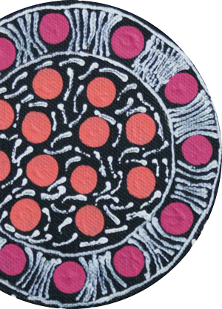
- How do you make links between the Australian Curriculum Mathematics and contexts beyond the classroom?
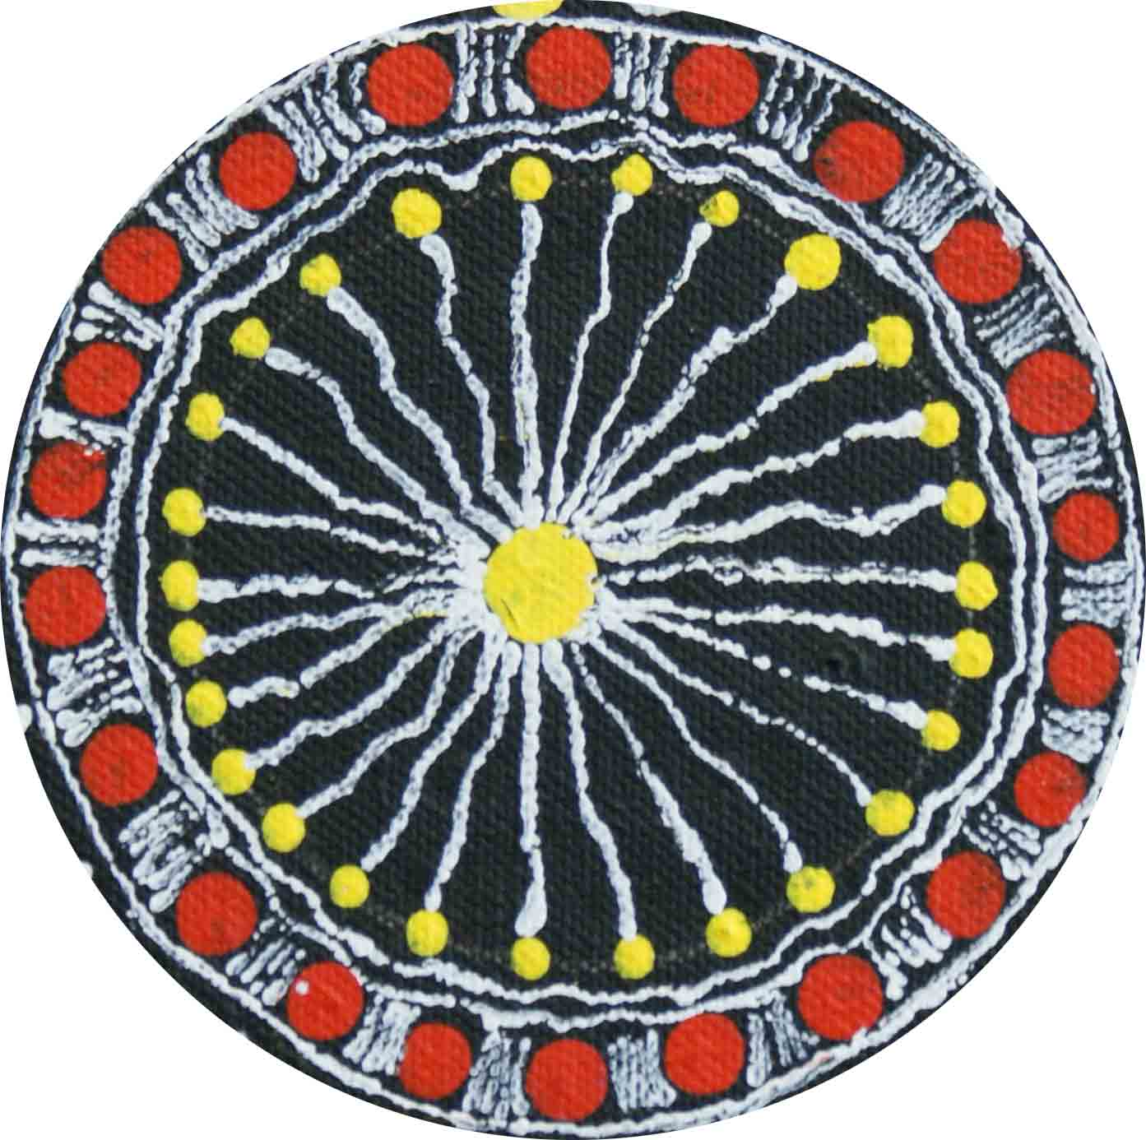
- What are the social contexts that your students are engaging in or interested in? What mathematics and numeracies are incorporated in these contexts?
Details from a painting by Angelina Doolan, Worawa Indigenous College, Healesville Cluster

